

University of Iowa
2026-2027

STUDENT-ATHLETE
HANDBOOK

DEPARTMENT OF INTERCOLLEGIATE ATHLETICS
THE UNIVERSITY OF IOWA

MESSAGE FROM
THE HENRY B. AND PATRICIA B. TIPPIE
DIRECTOR OF ATHLETICS CHAIR
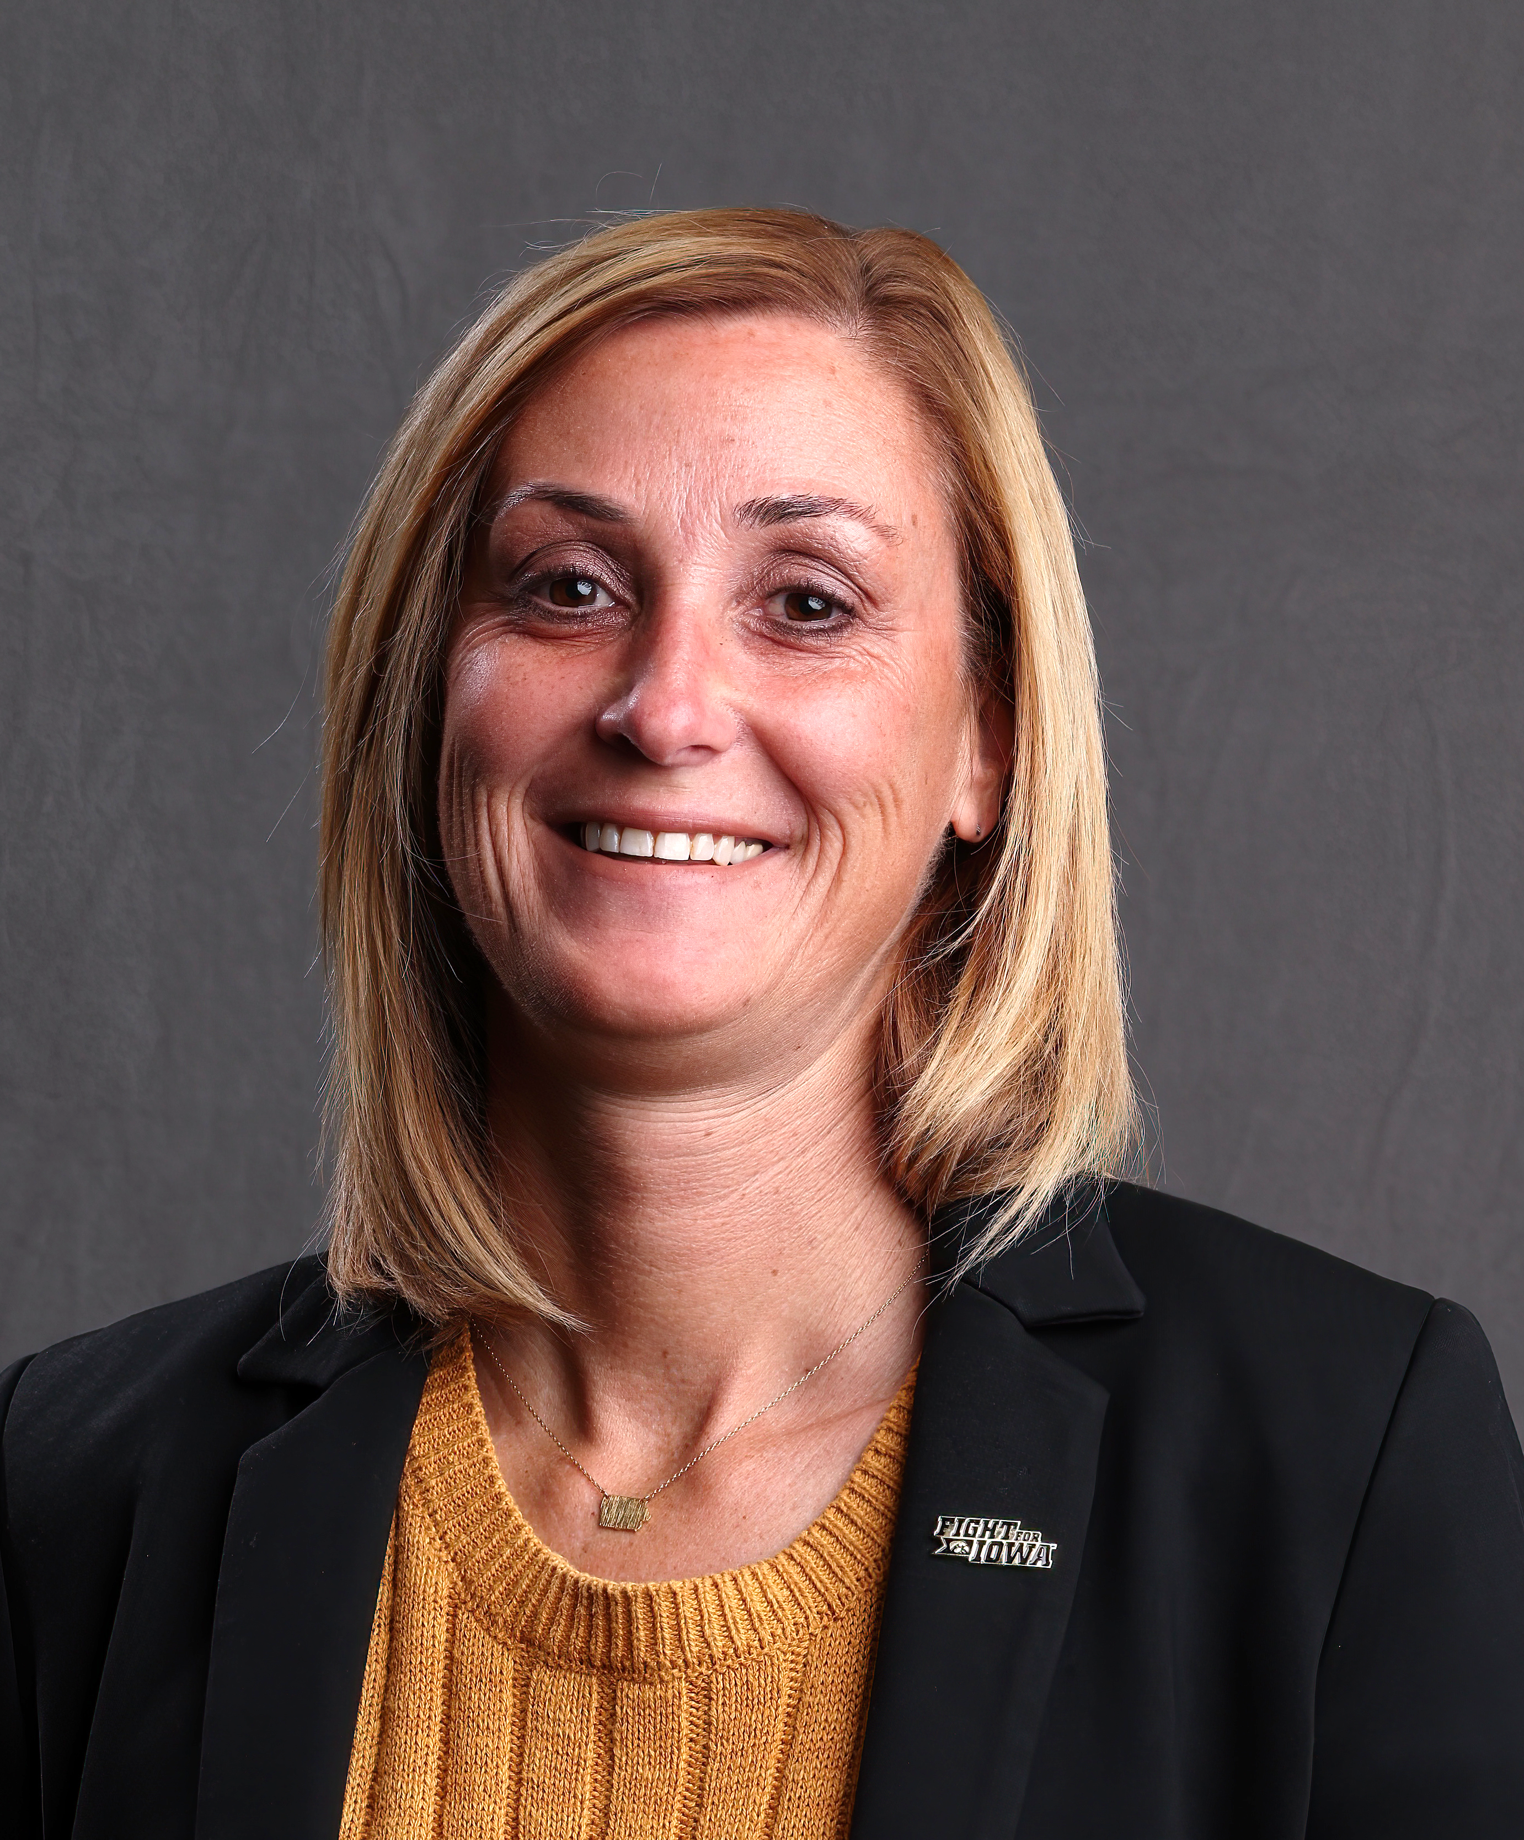

Welcome hawkeyes:

On behalf of the University of Iowa Athletic Department, we are excited to have you in the Hawkeye family this year. Whether you are a new or returning student-athlete, you have an incredible opportunity to earn a degree from the University of Iowa, a world-class institution, while competing in the prestigious Big Ten Conference.

The sights and sounds of a new year are all around us, and I am excited to kick off what is sure to be a successful year. Winning in the classroom and in competition is a byproduct of a commitment to pursuing championships with character. This ensures that success, both now and in the future, will always be a part of your journey. We will provide you with every available resource, but it is your responsibility to dedicate yourself to your studies and compete to the best of your ability, all while growing into the leader we know you can become. Use this handbook as a guide throughout this incredible journey, and you will excel in all that you do.

It is truly a privilege to wear the Hawkeye black and gold as you represent so many who came before you and those who will follow. Make it special and commit to doing everything possible to reach your potential. We hope you have an enjoyable and successful year and wish the best of luck to all our teams.

Together, We Fight For Iowa. Go Hawks!

Beth Goetz
Table of Contents
ATHLETICS DEPARTMENT SUMMARY 5
Student-Athlete Handbook Purpose 5
Mission Statement 5
Iowa Athletics Department Core Values 5
DEPARTMENTS & PEOPLE 6
Administration 6
Code of Conduct 6
Drug Testing 6
End of Season Survey 6
Athletic Performance 7
Compliance 7
Athletic Aid Appeals Process 7
Book Policy 9
Certification Meetings 9
Civic Engagement 9
MyPlaybook Modules 10
Sports Wagering 10
Student-Athlete Parking Policy 2026-27 10
Teamworks 12
Time Management Plan Policy 12
Transfer Policy/Procedures 12
Counseling and Performance Psychology 13
Equipment Room 13
Faculty Athletics Representatives 14
Iowa Letterwinners Club 14
ISAAC 14
Marketing/Strategic Communications 14
Name, Image, Likeness (NIL) Education 14
Presidential Committee on Athletics 15
PCA Policies Manual 15
Sports Medicine-Athletic Training 15
Sports Nutrition 16
Student-Athlete Academic Services 17
Academic Misconduct 17
Advising 17
Declaration of Major 18
Deficiency Letters 18
Eligibility 18
Enrollment 19
Athletic Aid 21
Degree Completion Program 22
Summer School Aid Policy 23
Winter School Aid Policy 24
Class Attendance 24
Team Travel 25
Hawkeye Life Program 25
Parking Pass Policy Near the Gerdin Athletic Learning Center 26
Tutoring Policy 26
UI Center for Advancement 27
FACILITIES 28
RESOURCES 30
Report A Problem 30
Campus Resources & Services 32
Admissions 32
Academic Resources 32
Advising 32
Billing & ID Card Service Center (Formerly UI Service Center) 32
Campus Involvement 32
Career 33
Colleges 33
Counseling Services 34
Dean Of Students 34
Financial Aid 34
Information Technology Services 34
International Programs 34
Libraries 34
Office of Civil Rights Compliance (OCRC) 34
Office of Enrollment Management 34
Student Disability Services 34

ATHLETICS DEPARTMENT SUMMARY

Student-Athlete Handbook Purpose
The Student-Athlete Handbook serves as a resource guide for student-athletes at the University of Iowa. All student-athletes are held responsible for the policies outlined in the handbook and are expected to carefully review the information along with corresponding web links.

Mission Statement
The mission of the Department of Intercollegiate Athletics is to provide administrative and coaching support, facilities, resources, and equipment necessary for student-athletes to graduate from The University of Iowa while competing successfully in broad-based championship caliber intercollegiate athletics. The overall well-being of the participant and the integrity of the program are paramount in all that we do.

Iowa Athletics Department Core Values
Excellence | Compete to win. Relentless pursuit of the highest levels of intellectual, personal, and athletic achievement.
Integrity | Adhere to NCAA rules, while being accountable to yourself, your team, the Conference, the University, and society.
teamwork | Work in collaboration with campus and community partners. We fight for Iowa.
Creativity | Strive to be innovative and a leader in college athletics.
Tradition | Respect the intense pride, loyalty and allegiance to the Hawkeye Family and its communities.
Leadership | Serve others. Be smart. Evolve.
Fiscal Responsibility | Stewards of the financial resources entrusted to us by donors, fans, and partners.
Access and Opportunity | Committed to creating and maintaining opportunities and a welcoming and respectful environment for all.

DEPARTMENTS & PEOPLE

Administration
The Henry B. and Patricia B. Tippie Director of Athletics Chair oversees the Department of Intercollegiate Athletics on behalf of the President of the University of Iowa. Senior Athletics Administrators supervise primary areas of the department, promote the mission and values, and provide oversight on policies and procedures while adhering to all university, Big Ten Conference, and NCAA rules and regulations. Oversight by this team includes business operations, capital projects, compliance, development and patron services, NIL & revenue generation, event management, external relations, human resources, information technology, sports performance, and student-athlete academic services. Sport Administrators are responsible for the supervision and management of sports teams; they work with coaches to guide the daily administration of programs.
https://hawkeyesports.com/staff-directory

Code of Conduct
The University of Iowa Student-Athlete Code of Conduct outlines behavioral expectations for student-athletes and describes the potential consequences of misconduct. All student-athletes are expected to comply with University of Iowa policies and the standards established by the Department of Intercollegiate Athletics. Access the complete policy in Teamworks under Administration Files or via the link: https://academics.athletics.uiowa.edu/resources.

Drug Testing
The purpose of the University of Iowa Department of Athletics Drug Testing (the Program) is to promote good health, safety, and excellent academic and athletic performance of student-athletes. The institutional in-house Program complements and supplements the NCAA year-round testing program, which is governed by the NCAA drug-testing manual. All student-athletes who participate in UI intercollegiate athletics are subject to unannounced drug screening examinations, as outlined in the Drug Testing Policy. The complete policy is available in Teamworks or at the following link:
https://academics.athletics.uiowa.edu/resources

End of Season Survey
The End of Season Survey is a yearly assessment tool that evaluates student-athlete experiences at the University of Iowa. The goal of the survey is intended to offer student-athletes an opportunity to share information about their experience during the season. The surveys are conducted anonymously to offer a confidential means of communication via the RealResponse platform. Survey results are compiled and reviewed by members of the Senior Athletic Administration as well as the Faculty Athletic Representatives. Sport Administrators are responsible for providing End of Season Survey feedback to the head coach as part of their yearly performance evaluation.
Key areas of evaluation:
- Health and Well-Being
- Academics & Student Development
- Team
- Athletic Department

Athletic Performance
Athletic Performance staff are responsible for constructing and implementing in- and out-of-season training programs for individual sports. Team training programs are developed in collaboration with coaching and sports medicine staffs. This unit is responsible for supervising and maintaining all weight training rooms.
Rules of Conduct:
- Weight Rooms are locked unless appropriate staff is present.
- Individuals are expected to be respectful of their teammates, staff and facility.
- Closed-toe athletic shoes and shirts must be worn at all times. Only University of Iowa logos and/or gear will be allowed.
- Water/Powerade is allowed in the training space of the weight rooms. Fueling station items must be consumed outside of the training space.
- All equipment should be returned to its proper location. Equipment should remain in the facility unless given approval by the athletic performance staff.
https://strength.athletics.uiowa.edu/
Locations: Carver-Hawkeye Arena, Jacobson Athletic Building, Stew and LeNore Hansen Football Center

Compliance
The mission of the Athletics Compliance Office is to advance The University of Iowa’s commitment to the highest standards and principles of ethical behavior and strict adherence to the letter and spirit of the NCAA and Big Ten rules. Staff members are responsible for providing compliance education to all Hawkeye stakeholders including student-athletes, coaches, recruits, fans, and donors; monitoring sports programs to ensure an atmosphere of compliance; and investigating and reporting Big Ten violations. This unit interprets and enforces the rules of the College Sports Commission, NCAA, and Big Ten Conference, which include amateurism and promotional activities, recruiting, initial and continuing eligibility, financial aid including scholarships and employment, extra benefits, and playing and practice seasons.
https://compliance.athletics.uiowa.edu/
Location: Carver-Hawkeye Arena (S240)

Athletic Aid Appeals Process
Athletic Grant Reduction, Cancellation or Nonrenewal Process and Appeal Procedures - Student Financial Aid Committee (Revised Summer 2023)

It is the responsibility of the Athletics Compliance Office to notify the Office of Student Financial Aid of the reduction or non-renewal of an athletic grant as soon as the decision is finalized by the coach or, in the case of a voluntary quit, the student-athlete.
It is the responsibility of Office of Student Financial Aid to notify the student-athlete in writing via email of the reduction or nonrenewal along with the reason. In accordance with NCAA rules, nonrenewal notifications are provided no later than July 1 after the period of the award. The student-athlete is also provided a copy of the appeal procedures. A committee comprised of individuals outside of the Athletics Department reviews the appeal. A representative from each of the following units will comprise the Committee:
- Office of the Dean of Students (voting member)
- Enrollment Management (voting member)
- Faculty Athletic Representative (voting member)
- Office of Student Financial Aid Athletic Liaison (non-voting member)
It is the responsibility of the student-athlete to submit, in writing, to the Assistant Director of Student Financial Aid, Scholarships and Athletics, an appeal no later than 15 calendar days of the issuance of the email of nonrenewal or reduction. In this written appeal, the student-athlete should outline all issues related to the appeal. The student-athlete must provide an explanation of why he/she believes the athletic grant should not have been reduced or cancelled. The student-athlete should provide as much information as possible, including documentation from outside sources.

Upon receipt of the student appeal, the Assistant Director of Student Financial Aid, Scholarship and Athletics will notify the Associate Athletics Director for Compliance and the Appeal Committee members (listed above) of the appeal and the need for an appeal hearing. The hearing should be scheduled within two weeks of the submission of the appeal.

The sport Head Coach must provide, within one week of the notification of the appeal, written documentation to the Assistant Director of Student Financial Aid, Scholarships and Athletics, regarding the circumstances that led to the decision to reduce or cancel the athletic grant. This time frame allows the Appeal Committee members to receive all documentation one week prior to the hearing. The student appeal and coach’s information will be provided to committee members at the same time.
In-Person Hearing:
- Participants will include:
  - Student-athlete
  - Committee members
  - Athletics Compliance staff representative(s)
  - Sport Head Coach or designee
- Participants may include:
  - Family member(s) of the student-athlete and/or advisor. If a family member is not able to be physically present but wishes to participate, he/she may do so electronically through conference call or skype, or other reasonable means.
  - Legal representation for the student-athlete, at the student-athlete’s expense.
  - Legal representation for the Athletics Department at the University’s expense (if needed).
- Format:
  - Unless there is a specific, pre-approved request by the student-athlete to meet separately with the Committee, all parties will meet together.
  - Each party (student-athlete and Athletics Department representative – either head coach or compliance staff) will provide opening statements.
  - The University will present evidence first followed by the student-athlete.
  - Committee members may question either party.
  - Each party will present closing arguments.
Time Frame:
- Within 15 calendar days of the issuance of the reduction or nonrenewal letter/email, the student-athlete must submit, in writing, and appeal to the Assistant Director of Student Financial Aid, Scholarships and Athletics.
- Within seven calendar days of the receipt of the appeal, the sport Head Coach or designee must provide written documentation regarding the circumstances that led to the cancellation or reduction of the athletic grant.
- Ordinarily, within 14 calendar days of the student appeal, the hearing will be held. Allowances may be made for extenuating circumstances.
- Within seven days of the in-person hearing, the Committee will render a decision in writing to the student-athlete and Associate Athletics Director for Compliance.
Standard of Judgement:
The University bears the burden of proving, by the preponderance of evidence, that the action disputed by the student-athlete was justified. The Committee will determine, based on the verbal and written evidence presented by the student-athlete and the Athletic Representative if the decision was justified. The Committee’s decision is final.

Book Policy
The Athletics Compliance Office will purchase all required textbooks for student-athletes on a book scholarship. Required textbooks will be ordered for the student-athletes based on their schedule in MAUI and they will receive an e-mail (to their uiowa.edu email account) from the bookstore where the books were ordered. All textbook orders and requests for books must be complete within the first three weeks of the term. No textbooks will be purchased or reimbursed for students after the start of the fourth week of the term. Student-athletes must pick up their textbooks from the bookstore within this time frame, otherwise the books will be returned and not available for the student-athlete. Exceptions will be made for classes added late or mid semester classes.

Purchased books for classes dropped during the drop/add period must be returned to the bookstore at the conclusion of the third week of class. Student-athletes will be charged the cost of the textbook when not returned by the deadline.

At the conclusion of the semester the student-athlete may keep their textbooks or sell them.

Certification Meetings
Certification meetings are held prior to the first day of classes as part of the student-athlete certification process. The Athletics Compliance Office provides information to students regarding athletics department, College Sports Commission, NCAA, Big Ten, and University of Iowa rules and policies. The meetings are mandatory for all student-athletes. In the event a student-athlete has a scheduling conflict, he/she must arrange a time to meet with the Athletics Compliance staff.

Civic Engagement
Student-Athlete Academic Services notifies athletes yearly regarding civic engagement-related opportunities - including, but not limited to, community engagement and service opportunities, Hawk the Vote educational programming and events, voting education materials, etc.

NCAA Policy on Civic Engagement
17.1.7.6 Required Day Off – Civic Engagement. All countable athletically related activities (per Bylaw 17.02.1) shall be prohibited on the first Tuesday after the first Monday in November. An institution shall develop civic engagement policies, which must address opportunities available to student-athletes for civic engagement, through a collaborative process involving student-athletes, coaches and senior athletics department staff members to ensure student-athletes are provided adequate opportunities, resources and programming to participate in civic engagement activities. (Adopted: 9/16/20 not applicable to contests scheduled before July 17, 2020, Revised: 6/15/22 effective 8/1/22)

17.1.7.6.1 Exception -- Championship Segment. A team that is participating in the segment of the playing season that concludes with the NCAA championship may engage in countable athletically related activities on the first Tuesday after the first Monday in November, provided student-athletes are given a day off from countable athletically related activities to participate in civic engagement activities and programming within 15 days before or after the first Tuesday after the first Monday in November. (Adopted: 6/30/22 effective 8/1/22)

MyPlaybook Modules
Per NCAA rules our department is required to conduct yearly training for student-athletes pertaining to their health and well-being. All student-athletes will complete required health and well-being trainings through the MyPlaybook online modules. Topics include sexual assault and violence prevention, alcohol and drug harm reduction, mental health resources, bystander intervention training, etc. You will receive more information regarding these required modules this summer with login instructions and due dates. Students are required to complete these modules before they are certified to be eligible to practice or compete.

Sports Wagering
NCAA Bylaw 10.3 prohibits student-athletes from participating in any sports wagering activity that involves intercollegiate or professional athletes. Any activity in which an individual must pay a fee to enter with the chance of receiving a prize is in violation of NCAA rules and can result in ineligibility for the student-athlete. Three important things to remember:
- Sports wagering activities that do not involve the outcome of contests are also not permitted (e.g., fantasy leagues, picking the top scorer).
- Cash is not the only prohibited item to be used as a wager; it is not permissible to bet with any other item that has tangible value, such as a shirt or a meal.
- Providing information about a student-athlete to individuals involved in sport wagering activities is prohibited.

Student-Athlete Parking Policy 2026-27
Purpose
Athletic automobile parking permits were established to help students with parking while working or attending practice and/or training in adjacent facilities. The Athletic Department has agreed to pay a portion (currently paying half the cost) of the permit and the student-athlete is responsible for the remainder of the charge. Student-athletes are required to register their automobile with the Athletics Compliance Office to qualify for the discounted program. The cost of the permit can be found on each permit type below.
Eligibility
- Sold on a first come first serve basis.
- Students living in university housing are not eligible.
- Students having a storage, Hancher, or commuter parking are not eligible.
- Students are allowed only one parking permit. Motorcycle permits are allowed to be combined with student permits.
- Student-Athlete permits work in the library lot (lot 3) as a registered vehicle to prevent tickets. The student is required to pay the hourly rate when parked.
- Permit does not guarantee a parking place.
Virtual Permits
Student athlete (SA) permits will be virtual permits only. Permits will be available for sale online in the Parking Portal.
For permit sale dates see the P&T Student Parking page For more information about virtual permits see the P&T License Plate Recognition page. (see the Parking dropdown menu.)
SA permits are sold on a first come first basis. Permits are available to order based on what is still available.

Permit | Available Online
Fall/Spring Permits | August 3, 2026
Summer Permit | May 3, 2027

STUDENT-ATHLETIC PERMIT COSTS AND LOCATIONS
COSTS
All permit locations have the same cost:
- Student Athlete All Day Permits: Cost $306.00/semester
- Athletic Cost $153.00/Semester Student Cost: $153.00/Semester
- Monthly rate $68.00 – Athletic Cost $34.00/month; Student cost $34/month
LOCATION AND CAPACITIES
- Hansen Performance Zone 5118 (former RB Meters) = 60
- Carver (Lot 47) = 80
- CRWC (Lot 11, access card required) = 20
- Gymnastics (Lot 66) = 50
- Hall of Fame (Lot 71/Zone 5137) = 50
BILLING
- SA permits will only be offered UBILL or credit card payments through the parking portal as payment options. All student parking permits are billed every fall and spring semester.
  - The first installment is billed at the time of purchase.
  - The second installment is billed January 1.
  - Summer permits bill one time for the summer session.
- P&T will continue to use the Athletics Compliance Department list of eligible athletes to confirm applicable permit charges. SA’s who are not on the eligibility list will be charged the full permit rate after reviewed by Athletics Compliance Office.
- SA’s who are on the eligibility list will be charged ½ the rate, while Athletics will be charged the remained ½ rate.
STUDENT-ATHLETE PERMITS POLICY
- Student-Athlete Permits only work in the designated parking location in which you pick except with the parking exceptions below. All parking permits should be parking in the parking area for permits rather than Park Mobile areas.
  - EXCEPTION the former RB Meter (Zone 5118 permits) only work in the Park Mobile parking area.
- Student Athlete Permits will be honored in Lot 35 when practice or weights are required at this location. Do not use the Park Mobile zone 5125 area, use the permit parking area ONLY.
- Student Athlete Permits are allowed to park in the library lot as the student registration permit.
- Student Athlete Lot 71 and Lot 66 permits will be allowed to park at Carver for weights for those sports required to be at this facility.
CHANGE VEHICLE INFORMATION
- Students can have one vehicle registered at any time, but vehicle information can be quickly updated in the Parking Portal by clicking “replace vehicle”. For step-by-step instruction on how to update your vehicle, see the Parking Portal Info page: https://transportation.uiowa.edu/parking/license-plate-recognition/parking-portal-info
- Vehicles must be updated before you park on campus. If the vehicle is not updated before parking, you may receive a citation.
CANCELING YOUR PERMIT AND REFUNDS
- To cancel your virtual permit, you need to complete the Cancel Permit Form: https://transportation.uiowa.edu/cancel-virtual-parking-permit. You will be charged for the permit until it is cancelled, or the permit expires.
- You will receive a refund if you cancel your permit before the end of the semester. Permit fees are prorated by the half month.
  - For example, if you cancel your permit on the 1st through the 15th of the month, your final charge will only be a half-month's charge. Permits cancelled from the 16th to the end of the month will pay a full month’s charge.

Teamworks
- Teamworks (ACADEMICS) is a team management platform that allows teams to mass communicate, organize data, schedule effectively, track progress and streamline paperwork. This is the primary collaboration tool for all coaches and Hawkeye student-athletes and can be downloaded at any smart phone app store. The platform helps student-athletes navigate and adapt to the demanding schedule of a Division 1 athlete. Teamworks is a way for Hawkeyes to:
- Coordinate schedules between practice, training, tutoring and travel.
- Connect and engage with teammates and coaches.
- Access athletic department resources at any time.
- Teamworks HUB is an online management system used by student-athletes, coaches, and athletics department staff members. Student-athletes may access forms related to NCAA Compliance Certification, summer school aid requests, complimentary ticket requests, and other resources through the Teamworks Hub.
Students may login in at: https://login.teamworksapp.com/app/zendesk/0oa6qaw4arb1qHzc44x7/login

Time Management Plan Policy
In conjunction with an annual playing season declaration, every sport program must develop a time management plan (TMP) to provide student-athletes with greater predictability and transparency in their athletic schedules for the upcoming academic year. TMPs are intended to provide student-athletes adequate advance notice of future athletically related activities in order to effectively plan their academic and non-athletically related activities. The following website has the full-time management policy: http://compliance.hawkeyesports.com/
Contact information: mason-collins@uiowa.edu

Transfer Policy/Procedures
It is the goal of the Athletics Department that every Iowa student-athlete graduates as a Hawkeye. A small number of student-athletes, however, may decide it is in their best personal interest to transfer to another institution. The NCAA has designed an educational transfer module to help student-athletes considering a transfer to make an informed decision. The NCAA requires all Division I student-athletes to complete the educational module prior to entering the Transfer Portal. The educational transfer module is located on the “Want to Transfer?” resource page at NCAA.org.
Once a student-athlete affirms completion of the module, the Athletics Compliance Office will then meet with the student to complete the Notification of Intent to Transfer form. The Athletics Compliance Office shall enter their information into the Transfer Portal within two business days of receipt of the Notification of Intent to Transfer form from the student-athlete.

The Athletics Compliance Office is responsible for completing all information in the NCAA Transfer Portal, including evaluating the student’s eligibility for any Transfer Exceptions. The student must provide written notification of transfer during the period specified for the applicable sport in order to enter the transfer portal, unless an exception is met (e.g. postbaccalaureate transfer).

At the time of submitting the transfer notification, if the student-athlete receives an athletics scholarship, the student’s athletics financial aid may be cancelled or reduced at the conclusion of the academic term. If the athletic aid is changed, the student will receive notification from the office of student financial aid.

If the Head Coach removes the student from the team roster, the student is no longer eligible to receive the following benefits and services from the UI Athletics Department:
- Athletics Facility Access (e.g. weight rooms, locker rooms, practice facilities)
- Fueling stations
- Black Card Meals/Additional Team Meals
- UI Apparel and Equipment (billed for equipment and apparel not returned per department policy)
- Complimentary Tickets to UI Athletic Events
Students receiving an athletics scholarship will maintain access to the Gerdin Athletic Learning Center, including the Student-Athlete Academic Services staff and tutors for the duration of their athletic scholarship.

Counseling and Performance Psychology
The mission of the University of Iowa Department of Athletics Sport Psychology Services is to provide psychological services to University of Iowa student-athletes that foster mental health and well-being, promote success in educational and athletic goals, and contribute to a safe, welcoming, and multi-culturally aware athletics department and campus community. Staff includes sport psychologists, a sports neuropsychologist and behavioral health clinicians who understand the unique personal, academic, and athletic needs of being an Iowa Hawkeye student-athlete. Staff offer confidential and multi-culturally competent counseling, individual and team performance psychology services, psychological rehabilitation from injury, ADHD and learning disability assessments, and neuropsychological evaluation for concussion. Mental skills training and team building activities are also available for teams. The first session typically lasts an hour. Sessions focus on discussing goals, strategies, and skill development to address concerns.
ALL SERVICES ARE PRIVATE AND CONFIDENTIAL.
Contact Information: patricia-espepfeifer@uiowa.edu
Locations: Sport Performance Suite, Lower Level of the Jacobson Athletic Building

Equipment Room
This unit is responsible for the storage, maintenance, security, purchasing, and inventory of all uniforms and apparel utilized by teams. Personnel work closely with compliance staff, athletic training staff, sport administrators, and coaches/sport operations staff to manage the seasonal issuance and retrieval of apparel, ensure accurate inventory tracking, and oversee the proper disposal of equipment and apparel.
Student-athletes are responsible for returning all issued items; any items not returned may be subject to billing.
https://hawkeyesports.com/staff-directory/department/equipment
Locations: S123 Carver-Hawkeye Arena and Lower Level, Stew and LeNore Hansen Football Performance Center, Goschke Family Wrestling Training Center, Jacobson Athletic Building,

Faculty Athletics Representatives
A Faculty Athletics Representative (FAR) is a member of the faculty appointed by the President to serve as a liaison between the institution and the Department of Athletics, and as a representative of the institution to the National Collegiate Athletic Association and the Big Ten Conference. The University of Iowa has two FARs who work in close collaboration with the Presidential Committee on Athletics, the Student-Athlete Academic Services Office, the Enrollment Management Office, and the Athletics Compliance Office, to provide oversight of academic integrity of the athletics program and serve as advocates for student-athlete equity and well-being.
Names: Nicole Grosland and Liz Hollingworth
Contact Information: nicole-grosland@uiowa.edu, liz-hollingworth@uiowa.edu

Iowa Letterwinners Club
The Iowa Letterwinners Club is dedicated to promoting and celebrating the legacy of Iowa Athletics while directly supporting the efforts and activities of all Hawkeye student-athletes now and in the future. Members of the Iowa Letterwinners Club are Iowa student-athletes who have been awarded a varsity letter, by the respective sport head coach, for competition on an intercollegiate athletics team at the University of Iowa. The Iowa Letterwinners Club oversees the Iowa Athletics Hall of Fame, letterwinner awards, events and team reunions, fundraising and engagement opportunities on the Iowa Letterwinners Club Network.
www.jointheiclub.com/letterwinners
Contact Information: iowaletterwinnerclub@foriowa.org

ISAAC
ISAAC is a student-athlete leadership group acting as the voice of student-athletes within the department, campus, conference, and NCAA. The committee also facilitates and engages in various programs, social events, and community engagement activities. ISAAC consists of an Executive Board, two representatives from each team, and there are at-large positions available as well.
https://academics.athletics.uiowa.edu/isaac
Contact Information: macy-anderson@uiowa.edu
Social Media Instagram: @uisaas (SAAS)

Marketing/Strategic Communications
This unit is responsible for proactively promoting the Department of Athletics and strategically building greater awareness of the Iowa Hawkeyes. The External Relations staff supports and enhances the branding efforts of our student-athletes, coaches, and programs by providing coverage and highlighting successes. External Relations consists of marketing, communications, content creation, social media, video production, graphic design, photography, BTN Student U, Hawkeye Sports Properties, Hawkeye Ticket Solutions, HawkeyeSports.com and Live Event Production.
https://hawkeyesports.com/staff-directory
Location: Carver-Hawkeye Arena (S300)

Name, Image, Likeness (NIL) Education
Iowa NIL Mission:
Iowa NIL is a cross-departmental effort that will create and oversee Name, Image, Likeness (NIL) educational programming for Hawkeye student-athletes. Iowa NIL programming provides all interested Hawkeye student-athletes and sports programs the opportunity to understand NIL rules and their individual NIL rights, while receiving training and resources to enhance their NIL potential.
Website: https://hawkeyesports.com/nil
NIL Education and Resources Contact: Scott Brickman, Associate Athletics Director for NIL Strategy & Revenue Generation / Senior Director of Development (scott-brickman@uiowa.edu)

Presidential Committee on Athletics
The Presidential Committee on Athletics (PCA) is the advisory committee for the University President and the Director of Athletics. The role of the PCA is to provide advice on athletics issues generally, and to recommend policies pertaining to the Athletics Department consistent with the rules and policies of the National Collegiate Athletics Association, the Big Ten Conference, the Board of Regents, and the University of Iowa. Committee composition includes University faculty, administrators, staff, students (including a student-athlete from the Iowa Student-Athlete Advisory Committee and from the Undergraduate Student Government), and alumnae. Three subcommittees are specifically charged to monitor, evaluate, and address issues of student-athlete well-being: The Student-Athlete Well-Being Subcommittee, the Academic Achievement Subcommittee, and the Policy and Legislative Compliance (PLC) Subcommittee.
https://president.uiowa.edu/presidential-committee-athletics
https://hawkeyesports.com/committee-on-athletics

PCA Policies Manual
Many policies are printed in their entirety on the following pages. However, the following policies can be found within the PCA Policies Manual at the following link:
https://president.uiowa.edu/presidential-committee-athletics
- Missed Class Day Policy – Appendix B
- Grievance Policy – Appendix C
- Social Media Policy – Appendix D
- Student-Athlete Code of Conduct Policy – Appendix F
- Student-Athlete Rights & Responsibilities – Appendix G
- Pregnancy and Parenting Policy – Appendix H
- Online Course Policy – Appendix I

Sports Medicine-Athletic Training
The Director of Athletic Training Services, in collaboration with the Director of Athletics and The University of Iowa Director of Sports Medicine, ensures that the Department has and follows best practices for medical and departmental compliance policies and procedures. Athletic Trainers work directly with student-athletes on injury mitigation; coordinate medical evaluations; and provide immediate care, referral, treatment, and rehabilitation. This office works in collaboration with a team of orthopedic surgeons and sport medicine trained family care physicians associated with The University of Iowa Sports Medicine Center.
https://sportsmedicine.athletics.uiowa.edu/
Locations: Carver-Hawkeye Arena, Stew and LeNore Hansen Football Performance Center, Jacobson Athletic Building, P. Sue Beckwith, M.D., Boathouse, Hawkeye Tennis and Recreation Center, Nagle-Duda Gymnastics & Spirit Squads Training Center, Campus Recreation and Wellness Center

Sports Nutrition
The University of Iowa Sports Nutrition program aims to optimize student-athlete health and performance through evidence-based nutrition strategies and a multidisciplinary approach. The program is administered by sports dietitians who work closely with sports medicine staff, sports performance and coaching staffs, and administration to carry out nutrition services in the following areas: clinical sports nutrition, performance nutrition, nutrition education, and nutrition provision. Services provided include, but are not limited to, individual nutrition consultations, team nutrition education sessions, access to nutrition education resources and platforms, nutrition supplementation oversight and provision, provision of meals and snacks via the Black Card Meal Program and athletics department fueling stations.
https://nutrition.athletics.uiowa.edu/
Contact Information: kira-blum@uiowa.edu
Sports Dietitian Office Location: Sports Performance Services Suite, Lower Level of Jacobson Athletic Building

Student-Athlete Academic Services
Student-Athlete Academic Services offers academic and personal support services to assist student-athletes in making timely and satisfactory progress toward degree completion. The Senior Associate Athletics Director for Academic Services facilitates the development and implementation of departmental systems and protocols that comply with University expectations, Big Ten Conference, and NCAA regulations. This unit assists with the recruitment of prospective student-athletes and the integration of students into University life while balancing their academic and athletic commitments. Staff members provide academic and personal counseling, a structured study environment, tutorial support, NCAA academic eligibility monitoring, student development programming, and facilitate communications with faculty and staff.

https://academics.athletics.uiowa.edu/
Location: Gerdin Athletic Learning Center

Academic Misconduct
A student-athlete who is charged with academic misconduct as defined by the University of Iowa’s policy on academic misconduct, or by the student-athlete’s home college, is required to follow University protocol and is subject to sanctions. Student-athletes are to be informed of academic misconduct charges by their respective collegiate office. Cases of academic misconduct are to be solely managed within individual colleges, involving appropriate faculty and staff. The Senior Associate Athletics Director for Student-Athlete Academic Services should be notified by the respective college of all academic misconduct cases in which a student-athlete is formally charged with academic misconduct. The Senior Associate Athletics Director for Student-Athlete Academic Services will notify the Faculty Athletics Representatives, Associate Athletics Director for Compliance, and the Executive Senior Associate Athletics Director of all cases. In cases where an institutional staff member employed by the Athletics Department is involved, the Athletics Human Resources Office will also be notified. It is the responsibility of the Student-Athlete Academic Services Office to ensure student-athletes follow proper University protocol. Faculty and staff are encouraged to report any suspected cases of academic misconduct involving a student-athlete to their respective collegiate office immediately.

Advising
An Athletic Coordinator monitors the academic progress of student-athletes in each sport program. Coordinators obtain academic information during weekly student meetings. Academic information is provided to coaches in a weekly academic report. Such reports can include student performance in individual classes, attendance, and general academic updates. At minimum, Academic Coordinators are required to meet with every student in their designated caseload for the purposes of monitoring academic progress and ensure compliance with institutional, Big Ten Conference and NCAA rules regarding degree progression. Academic Coordinators document their communications with students by logging the date and essence of each meeting in a secure student database management system. If a student is absent to a meeting with their Academic Coordinator, coaches are notified of the absence. Academic Coordinators are expected to hold team academic meetings once per month during the regular academic year with each of their assigned sport programs.

In addition to Academic Coordinators, student-athletes are assigned a university advisor in the student’s designated degree program. Academic Coordinators consult with both students and university advisors to develop and maintain updated plans of study, set goals, build schedules, provide information on majors and help facilitate a student’s progression toward a degree program.

All current student-athletes must meet with their university advisor at least once per semester, commencing with their initial registration during orientation. Students, in consultation with their advisor, complete a plan of study each semester. The plan of study includes required coursework within their primary program of study, intended graduation date, advisor’s signature and contact information. Plans of study are updated each term and should reflect the course recommendations of the university advisor.

Declaration of Major
Student-athletes must have a declared major on file by the start of their 5th full-time semester in school. Students who have earned their baccalaureate degree may declare as a degree-seeking or non-degree-seeking graduate or undergraduate program of study. Students may only declare their major with the permission of an assigned university advisor. Academic Coordinators, coaches or athletics department staff members are not permitted to declare a major for a student-athlete.

Deficiency Letters
Student-athletes who are deemed academically ineligible are sent a deficiency letter, which outlines academic criteria for athletic reinstatement. Faculty Athletics Representatives, Sport Administrators and Academic Coordinators are all sent a copy of the letter.

Eligibility
Students should use the following academic progress standards during the advising and enrollment process. Failure to adhere to these guidelines may result in a student being academically ineligible.
NCAA Academic Requirements:
At all times students must pass a minimum of 6 credit hours each term (a minimum of 9 hours completed for football student-athletes during the fall term), and 18 credit hours between the fall and spring semesters each academic year.
The credit hours must be degree applicable starting the student’s third year of full-time enrollment.

Entering a student’s... | GPA Required | Minimum Degree Progress Requirements
Second Year | 1.80 | 24 hours earned
Third Year | 1.90 | 40% of degree completed
Fourth Year | 2.00 | 60% of degree completed
Fifth Year | 2.00 | 80% of degree completed
Big Ten Academic Requirements:
Students in their first year must complete a minimum 24 hours at the certifying institution during the academic year.
Grade-Point Average Calculation – Incompletes or Conditional Grades count as zero grade points in a student’s UI grade point average used for eligibility and certification.
UI Academic Progression Guidelines:
To help assure that student-athletes remain on a four-year graduation track, all student-athletes are encouraged to successfully complete 30 credit hours each academic year (the Fall, Spring, and Summer terms). Student-athletes enrolled at mid-semester will be strongly encouraged to complete the 30 hours prior to the start of the following spring term. An exception to the completion of 30 credit hours per academic year is a student-athlete who is in their last year prior to graduation.

Enrollment
All student-athletes must be enrolled full-time (12 hours for undergraduates/9 hours for students in grad school), unless:
- Student is in their final term of enrollment prior to graduation and needs less than full-time enrollment to complete degree requirements
  - Students must complete a Less Than Full-Time Enrollment Form found in their MyUI under Student Information/Registrar Forms/Athletics
- Per PCA Policy, all student-athletes must be enrolled in at least one face-to-face, in-person course
Less Than Full-Time Enrollment Form
Student-athletes may compete while enrolled less than full-time (i.e. less than 12 credit hours) if the student is in the final semester and enrolled in the coursework necessary to complete the degree requirements within a primary program of study. Students who enroll in less than 12 credit hours and do not graduate at the end of the term will have their remaining eligibility forfeited. Eligible students should work with the Academic Coordinator and submit a Less Than Full-Time Enrollment Form found on the UI Office of Enrollment Management website: https://registrar.uiowa.edu/forms
Plans of Study
- All student-athletes must meet with their on-campus advisors to discuss course recommendations for the upcoming term
- These recommendations are usually placed in the advising notes
Post-Graduate Students
- Students graduating in the spring, but have fall eligibility remaining need to speak to their academic coordinator about program options and how to get authorized to register.
  - Students may choose to apply to a graduate program, a 2nd undergraduate degree, a non-degree seeking program (graduate or undergraduate), or a minor or certificate program
  - If choosing a graduate program, you must contact the graduate college to discuss programs and course options. Students can either apply as a graduate student to the program of their choice (https://grad.admissions.uiowa.edu/new-students) or apply as a nondegree graduate student (https://grad.admissions.uiowa.edu/new-students/nondegree-seeking-students)
- Students in graduate non-degree seeking programs will need to contact the Graduate College for course selection and registration authorization
  - Students seeking a 2nd undergraduate major or non-degree seeking program, minor or certificate program need to contact their academic coordinator and put in writing their request to enroll in a 2nd undergraduate degree, non-degree seeking program, or a minor or certificate program
- The academic coordinator will notify admissions of the request
- Admissions will note the 2nd undergraduate degree, non-degree seeking program, or a minor or certificate program in MAUI
      - Students in a 2nd undergraduate degree, a minor or certificate program need to contact their advisor for course selection and registration authorization
      - Students in undergraduate non-degree seeking program will need to contact the Academic Advising Center for course selection and registration authorization

  - Degree applicable courses
- Only degree applicable courses can be used to meet the 6 Hour Rule for graduate programs, 2nd undergraduate degrees, or a minor or certificate program
- For non-degree seeking programs any courses can be used to determine the 6 Hour Rule
  - Students in a graduate program, a 2nd undergraduate degree, a non-degree seeking program (graduate or undergraduate), or a minor or certificate program must be enrolled full-time (9 hours for grad school/12 hours for undergraduates)
- However, students needing less than full-time enrollment to complete a graduate program, 2nd undergraduate degree, a non-degree seeking program (graduate or undergraduate), or a minor or certificate program may be enrolled in only the courses needed to complete the degree, minor or certificate program
- Students must submit a Less Than Full-time Enrollment Form
Summer Courses Taken at Another College or University
- To ensure students receive credit for summer courses taken at another college or university other than Iowa, students must complete the following form: Student-Athlete Request to Enroll in a Course Offered by a College Or University Other Than The University Of Iowa
- This form is found in the student’s MyUI under Student Information/Registrar Forms/Athletics
Non-Traditional Course Forms
- Students requesting to enroll in an Independent Study course or a research practicum must complete a Non-Traditional Course Form available on the University of Iowa’s Enrollment Management page (https://registrar.uiowa.edu/forms)
- A syllabus or signed agreement between the instructor and the student that outlines the requirements and due dates for the course must be submitted with the form.
- The form is to be signed by the Registrar’s Office, the Senior Associate Athletics Director for Student-Athlete Academic Services and the Faculty Athletics Representatives.
Student-Athlete Conflict of Interest Form
- To protect the integrity of University of Iowa academics and to address potential or actual conflicts of interest, the Student-Athlete Conflicts of Interest Form asks student-athletes to complete a disclosure of possible courses with personal or professional conflicts. While course enrollment is not prohibited due to a relationship, disclosure allows for potential and actual conflicts to be reviewed and managed appropriately.
- The certification process also asks whether an individual has a personal or business relationship with someone who supervises a current class. This question assists with identifying relationships that may require a management plan.
- Student-athletes request this form from their academic coordinator
Transfer Student-Athlete Evaluation Process
- Evaluation by Admissions Office – Pre-application
  - Athletics Compliance Office coordinates transcript review
  - Admissions will determine admissibility and provide estimated number of transferable credits, but not estimated degree applicable credits in the major (as applicable)
- Applying to Iowa
  - Transfers apply via the University of Iowa Application
- Students access the application on www.uiowa.edu and click on the Admissions link.
  - Application fee is $55. Athletic scholarship recipients receive an application fee refund
  - Official transcripts from every college or university attended must be submitted directly from the issuing institution.
- After Accepting Admission
  - Acceptance fee is $325. Athletic scholarship recipients receive an acceptance fee refund.
  - After accepting admission, Office of the Registrar (the certifying officer) and Student-Athlete Academic Services (SAAS) staff will simultaneously review the student’s degree audit to evaluate whether the student will meet progress toward degree (PTD) in their chosen major
  - Students can have a syllabus evaluated for a major and/or GER requirements assuming the course is already showing as elective credit
  - Students should consult with his/her University assigned academic advisor
  - If a student believes a transfer course/courses should meet major requirements, the student can complete an Athletic Transfer Syllabus Evaluation Request (found in MyUI/Registrar Forms)
- Students submit syllabi for courses not initially thought to meet major requirements
  - Grades in progress from the previous institution are noted on the degree audit, but are not listed as GE/major/electives
- The courses will remain in progress until the courses are complete and a final transcript is received
  - High School Transcripts/World Language Requirements
- Students must have their high school send an official transcript sent to the Admissions Office to determine status of World Language fulfillment
- Other Transfer Resources
  - Various resources are available to unofficially evaluate whether courses are transferable
- Site to locate transfer equivalencies
      - UI Search
Use this search utility to find courses at non-UI institutions that will transfer to the UI.
      - Transfer Institution Search
Use this search utility to show transfer course(s) accepted by UI college(s).
      - Transferology
After adding your courses to Transferology, students will be able to see how previous courses taken apply to the University of Iowa and the degree requirements they satisfy.

Athletic Aid
Athletic aid is available for student-athletes who can no longer compete due to an athletically related injury or who have exhausted their eligibility. The aid is intended to support students with the completion of their primary degree program. Students must submit an Athletic Aid Request Form to the Senior Associate Athletics Director for Student-Athlete Academic Services. Such requests are subject to review each term. Aid requests must be supported by the Student-Athlete Academic Services Office, Athletics Compliance Office, Head Coach and Sport Administrator.

Students who have completed their undergraduate degree program, exhausted their eligibility, and have been admitted to a degree-seeking graduate program while competing, may request aid.

Student-athletes who transferred into the University of Iowa, are enrolled in a graduate program of study, and have exhausted their eligibility may apply for athletic aid to complete their degree. Students must submit an Athletic Aid Request Form to the Senior Associate Athletics Director for Student-Athlete Academic Services. Funds may be used for tuition and fees and cannot be applied retroactively.
Academic Progress Clause
All students who have exhausted their eligibility and who are receiving aid are required to meet with their academic coordinator. At the end of each term, a student’s academic progress will be reviewed by the Student-Athlete Academic Services Office. Students are required to meet minimum NCAA and Big Ten progress toward degree guidelines as well as remain in academic good standing within their respective college. Students must enroll in and complete full-time enrollment each term unless they are in their final semester and will complete all course requirements necessary for graduation. Students who fail to meet the above standards may have their athletic aid revoked. Cancellation of aid for any of the above reasons will be at the discretion of the senior athletic administration.

Degree Completion Program
The Degree Completion Program assists former student-athletes, who have exhausted their eligibility, with completing their primary undergraduate degree program.
Degree Completion Program Requirements
Students must be within 30 credit hours of graduation, completed their eligibility at the University of Iowa, and received athletic aid. Students who transferred and matriculated to another institution do not qualify for the program. Students who do not meet these criteria may be approved for aid at the discretion of the senior athletic administration. Students accepted for the degree completion program may enroll in up to 15 semester hours of coursework per semester and qualify up to the same percentage of aid they received while competing as a student-athlete (excluding room and board). Aid will only be allocated toward tuition, fees, and books for coursework taken at the University of Iowa. Students taking coursework outside of the University of Iowa should obtain and complete a Transferability Form from the Student-Athlete Academic Services Office. Approved aid will be subject to review at the end of each term up until the time of graduation. Students who fail or withdraw from coursework may be subject to repaying tuition costs and will not be approved for further aid.
Degree Completion Academic Support
Upon re-enrollment, students may request academic assistance through the Student-Athlete Academic Services Office. Assistance may include, but is not limited to, free tutorial services and academic counseling.
Contact Information: Athletic-Academics@uiowa.edu
STEP 1: Degree Analysis
- Students must notify Student-Athlete Academic Services of their intention to complete their undergraduate degree from the University of Iowa.
- Students are responsible for contacting their respective college and/or major office to request an academic review.
- The college and/or major office will confirm remaining degree hours, specified coursework, and any additional degree requirements needed for degree completion.
- Students who have not been enrolled at the University of Iowa for more than 12 months must apply for readmission prior to enrollment.
STEP 2: Aid Request
- Upon verification of re-admission, students requesting athletic aid through the Degree Completion Program will be emailed a Degree Completion form, which should be submitted to the Senior Associate Athletics Director for Student-Athlete Academic Services.
- The Degree Completion Form must be supported by a Senior Athletic Administrator. Once approved, the Athletics Compliance Office will review the application and availability of athletic aid funds.
- Approved students will be notified of their aid amount.
- The Athletics Compliance Office will distribute funds accordingly.

Summer School Aid Policy
Students requesting summer athletic aid must submit a Summer School Application through Teamworks. Athletic aid is available but is not guaranteed.
Guidelines
- Students must apply for summer athletic aid, be approved, and submit a Summer School Acceptance Form before athletics aid is disbursed.
- Students must be eligible to receive athletic aid per NCAA rules.
- Students may receive summer athletic aid to cover up to 3 semester hours of UI coursework in their primary program of study. Students will receive aid during the summer term in which they are enrolled. Students enrolled in more than 3 credit hours of coursework for eligibility purposes may be approved.
- Any students who meet the summer activities exemption (i.e., football, men’s basketball, and women’s basketball) do not need to enroll in summer school classes to receive room and board.
- Students requesting summer athletic aid must submit a Summer School Application after they have enrolled in classes during the summer priority registration period.
- Students enrolled in summer school are held to the Academic Services Personalized Academic Support Plan requirements.
- Incoming non-scholarship student-athletes may request summer athletic aid (i.e., tuition, fees, books), and enroll in a maximum of 3 credit hours. Students on athletic aid may receive the equivalent of their athletic aid during the academic year or tuition, fees, and books whichever is greater, and enroll up to 3 credit hours.
- Students receiving room and board must reside within the Iowa City or surrounding community to receive room and board.
Repayment Clause
Students who fail, withdraw, or transfer may be billed the cost of tuition for the course unless they have extenuating circumstances (i.e., unforeseen circumstances that would prohibit a student from completing a course such as a personal or family emergency).

Students will be billed the full tuition amount of each course that is covered by the Athletics Department. The following conditions could result in summer school aid being billed to a student-athlete’s U-Bill account:
- Coursework in which a student enrolled, but for which athletics aid was not approved
- Courses dropped after the full-tuition refund period
- A student received a failing grade for a course during the summer term
Important Dates and Deadlines:
- February - College advisor meetings (obtain a plan of study signed by a college advisor).
- Coordinators send student-athletes’ applications through Teamworks, if applicable.
- March - Summer school priority registration period
- May 1 - Deadline to submit a Summer School Application along with a plan of study through Teamworks.
Applications received after this deadline will only be reviewed in cases where a student is deemed academically ineligible after the spring term.
Approval Process
Summer school applications are reviewed by the following:
- Academic Coordinator
- Athletics Compliance
- Sport Coach
Summer school applications will receive final approval by the Senior Associate Athletics Director for Student-Athlete Academic Services.
Priority
Priority will be given to:
- Fall sport teams.
- Teams participating in summer activities.
- Returning students.
- Students who submitted a Summer School Form prior to May 1.
- Students who need summer school to become academically eligible.
- Students whose required courses cannot be taken during the year; or
- Students who need coursework to graduate in 4 years.

Winter School Aid Policy
Students requesting athletic aid for the winter term must submit a written request to the Senior Associate Athletics Director for Student-Athlete Academic Services. Athletic aid is available, but is not guaranteed, and is reserved for students on tender/scholarship.

Class Attendance
The Athletics Department has a class attendance policy that encourages student-athletes to prioritize class attendance daily. Student-athletes are expected to attend every class session. When a student is unable to attend class due to team travel or health-related concerns, the Student-Athlete Academic Services staff will notify a student’s instructors. If a student is unable to attend a designated class due to illness, injury or personal reasons, the athletic training staff, team physician or approved department staff member will provide the Senior Associate Athletics Director for Student-Athlete Academic Services and the respective Academic Coordinator with documentation to excuse the student from class or tutorial appointments. A student’s Academic Coordinator is responsible for notifying students’ instructors. Academic Coordinators must copy the Senior Associate Athletics Director for Student-Athlete Academic Services on all email correspondences to instructors regarding missed class time.
The following protocol should be followed for any student-athlete who is absent from class due to a medically related reason that extends five or more days. A determination will be made if an Academic Recovery Plan be put in place for the student based on one of the following criteria:
- Level of impact on academic progress in one or more courses
- Student is receiving assistance from Student Disability Services
- Student is not actively participating in sport related activities
Protocol
- Athletic training or staff psychologist notifies Student-Athlete Academic Services of medical treatment and the duration of time a student will be absent from class.
- Student-Athlete Academic Services will notify all course instructors and the student’s campus advisor per the procedure for medically related class absences.
- If a student is absent from class for five or more days, a meeting will be scheduled with the Associate Athletics Director for Academics, Head Athletic Trainer, Director for Academic Services, Academic Coordinator, and the Associate Athletics Director for Advising and Eligibility.
- The Associate Athletics Director for Academics will communicate relevant information to the Tutoring and Retention staff.
- The Associate Athletics Director for Advising and Eligibility will work with the student-athlete and course instructors to set deadlines for missed coursework.
- Compile all missed coursework and tasks and provide to the Tutoring and Retention staff.
- Ensure regularly scheduled meetings are occurring between the Academic Coordinator and student-athlete.
- Ensure a follow-up meeting occurs between the Associate Athletics Director for Academics, Coaches, Athletic Training Staff, and the Academic Coordinator.
- The Academic Recovery Plan, which should be submitted to the Director for Academic Services, will be in place once a student is medically released and include the following:
- Evaluation of all courses and grades
- Missed exams or participation points
- P.A.S.S. Plan and monthly assignment calendar
- Additional academic support needs from the Tutoring and Retention staff
- Alert to Campus Care Team (if applicable)

Team Travel
The Department of Athletics is committed to the health and safety of Iowa student-athletes. The University of Iowa has a travel policy in place that will provide guidance for fair, equitable, and safe travel. It outlines general expectations including permissible modes of transportation, expectations for drivers, hotel accommodations and safety guidelines.

See your coach or sport administrator for a complete copy of the Team Travel Policy.

Absences due to university or athletics sponsored events are considered excused, per the University Operations Manual – Part IV. However, students must adhere to the attendance policies as outlined in their course syllabi. Non-collegiate outside competitions are not considered excused absences and students must arrange with their instructors to make up missed classwork. Non-collegiate outside competitions must be approved by the Faculty Athletic Representatives, Sport Administrator, Athletics Compliance, and Academic Services.

For team related competitions away from campus, the Academic Services staff is responsible for communicating with instructors about missed class time. Instructors receive notifications at the beginning of each semester regarding the travel schedule for all student-athletes who will compete during the course of the semester. Instructors are sent a reminder notification the week of each competition alerting them that a student-athlete will be absent from class due to a team competition. Travel notifications to instructors are sent once the Academic Services staff receives the travel itinerary. Students should communicate with their instructors prior to traveling about potential missed classwork and must make up work in a timely fashion. For additional information about student absences, visit the following link:
https://president.uiowa.edu/presidential-committee-athletics

Hawkeye Life Program
The Hawkeye Life program is an all-encompassing life skills and leadership development model which seeks to enhance the student-athlete experience at The University of Iowa. Hawkeye Life offers student-athletes’ educational opportunities beyond their athletic and academic responsibilities. The program encourages student-athletes to get involved, to be good citizens, and to take an active role in their personal and professional development. The model includes five pillars: Leadership, Community Engagement (sponsored by MidAmerican Energy), Academic Success, Career Development, Health & Well-Being.

To support participation in Hawkeye Life programming and community engagement opportunities, Helper Helper is the online platform used to register for programs and track community engagement and service hours. Student-athletes may access participation records and engagement reports throughout their time at Iowa.
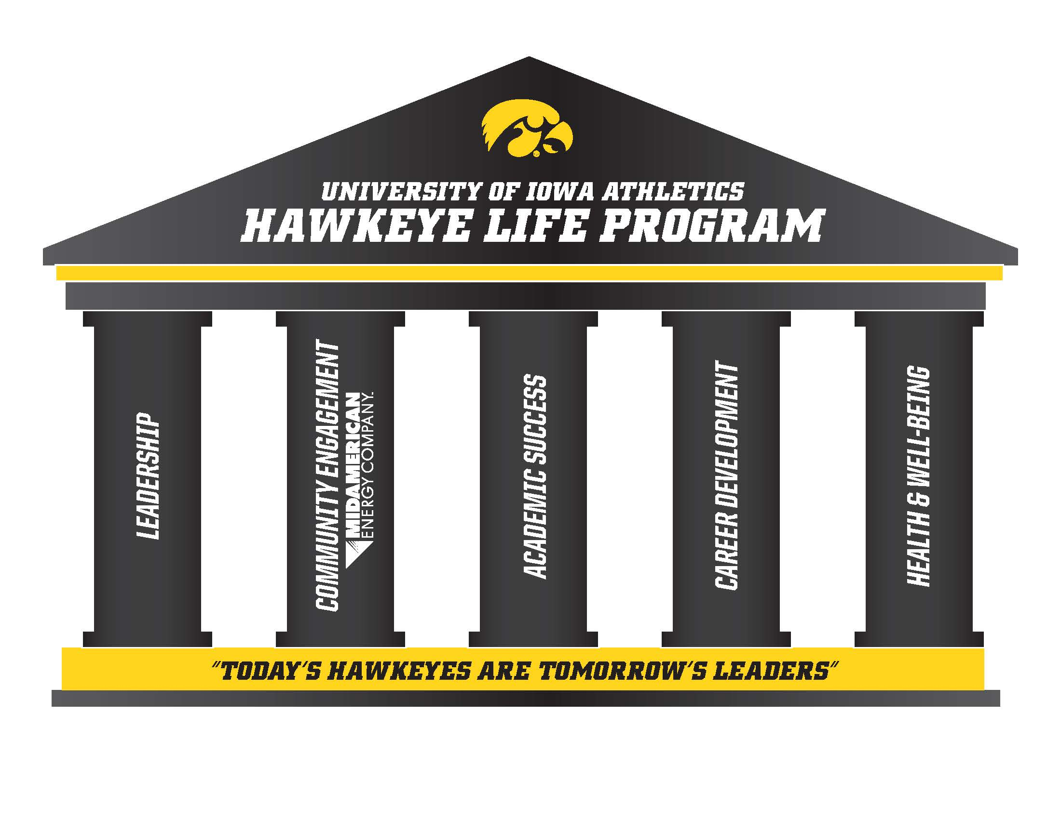
For more on the Hawkeye Life program, visit: https://academics.hawkeyesports.com

Parking Pass Policy Near the Gerdin Athletic Learning Center
- The Student-Athlete Academic Services Office provides 1-hour parking passes to student-athletes who utilize the Gerdin Athletic Learning Center and have registered their vehicle with the Athletics Compliance Office. Parking pass eligibility and distribution procedures are subject to Athletics Department parking policies.
- Parking passes issued pursuant to this policy are valid for the Field House Parking Ramp and Parking Lot 14 (located north of the Gerdin Athletic Learning Center). Please note that parking in both locations is subject to availability.
- Parking passes may be requested from the first-floor front desk staff, and all requests must be signed by the student-athlete. Because parking in the Field House Parking Ramp and Lot 14 is free for the first 30 minutes, passes will only be distributed to student-athletes who require parking for more than 30 minutes. Parking privileges may be revoked for misuse.

Tutoring Policy
Tutoring is available free of charge to all student-athletes, managers, student trainers, and spirit group members. If a tutor is unavailable for the requested subject, the student-athlete is referred to alternative tutoring resources provided on campus.

Academic Support Requests and P.A.S.S. Program
Student-athletes may request tutoring and other academic support services through the Personalized Academic Support System (P.A.S.S.). In collaboration with their Academic Coordinator, student-athletes may develop an individualized academic support plan designed to meet their academic needs. Support services may include tutoring, learning assistance, Academic Support Initiative (ASI) services, meetings with Learning Specialists, faculty office hours, and other academic resources available through Student-Athlete Academic Services and the University of Iowa.

Tutoring sessions will be arranged by the Tutoring and Administrative Services Specialist for Student-Athlete Academic Services and will be held in the Gerdin Athletic Learning Center. The Tutoring and Retention staff reviews all student-athlete requests and communicates tutoring schedules to students, tutors and academic coordinators. Each tutoring session is documented by the tutor and is reviewed daily by the Assistant AD of Academics. A copy of each tutoring log is sent to respective coaches and Academic Coordinators.

Student-athletes are required to attend all meetings with Academic Services staff members, including tutorial appointments. Students must provide the Tutoring and Retention staff 24 hours’ notice if the student needs to be absent from an assigned tutorial appointment. Student-athletes are allowed one unexcused absence. A student-athlete will incur a $10 charge for their second absence, with charges increasing in $10 increments for any subsequent absences (i.e. $20 for third absence, $30 for fourth absence, etc.). Charges will be applied to the student-athlete’s U-Bill. After a third absence, the student will be temporarily suspended from their academic support until they meet with the Assistant AD for Academics to discuss possible reinstatement. Academic Coordinators and coaches will be made aware of any academic support absences.

UI Center for Advancement
The UI Center for Advancement (UICA) is responsible for fundraising and alumni engagement activities on behalf of Iowa Athletics. The Athletics Development staff coordinates all fundraising activities and conducts more than 70 annual events for the Hawkeyes. Each year the Athletics Development office strives to not only help offset growing scholarship costs, but to provide private funding to advance competitiveness and academic performance. Athletics Development is comprised of three main fundraising arms:
- Athletics Annual Giving coordinates annual giving from fans and alumni to the I-Club Fund (general athletic budget expenses for seating related gifts), to the Hawkeye Scholarship Fund (exclusive support for tuition, room, board and costs of attendance) and to the sports development funds of each of our athletics teams.
- Endowed Scholarship support through the Hawkeye Visions Scholarship program allows Iowa Athletics to reimburse The University of Iowa for the cost of student-athlete scholarships, through generous and loyal supporters.
- Capital Projects are designed to provide our Hawkeyes with the best facilities and equipment needed to train and compete with the best in the Big Ten Conference, and the nation. Funding comes from private philanthropic investments from Hawkeye fans, friends of the University, and departmental revenues.

The Athletics Development team hosts a variety of events including named scholarship events, Hawkeye Huddles, the annual student-athlete thankathon and more.
http://jointheiclub.com
Location: Levitt Center for University Advancement

FACILITIES
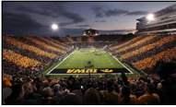 |  | 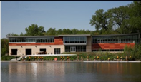 |  | 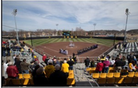
KINNICK STADIUM |  | P. SUE BECKWITH, M.D., BOATHOUSE |  | BOB PEARL SOFTBALL FIELD
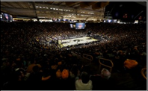 |  | 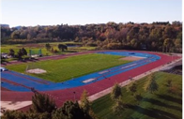 |  | 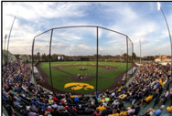
CARVER-HAWKEYE ARENA |  | CRETZMEYER TRACK |  | DUANE BANKS FIELD
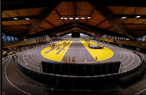 |  | 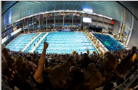 |  | 
IOWA INDOOR TRACK BUILDING |  | CAMPUS RECREATION & WELLNESS CENTER |  | BILL AND JIM ASHTON CROSS COUNTRY COURSE
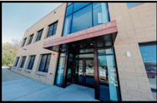 |  |  |  | 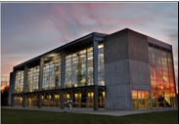
GERDIN ATHLETIC LEARNING CENTER |  | FINKBINE GOLF COURSE |  | ROY G. KARRO ATHLETICS HALL OF FAME
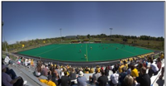 |  | 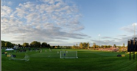 |  | 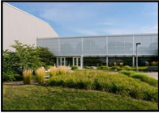
DR. CHRISTINE H.B.  GRANT FIELD |  | IOWA SOCCER COMPLEX |  | HAWKEYE RECREATION TENNIS CENTER
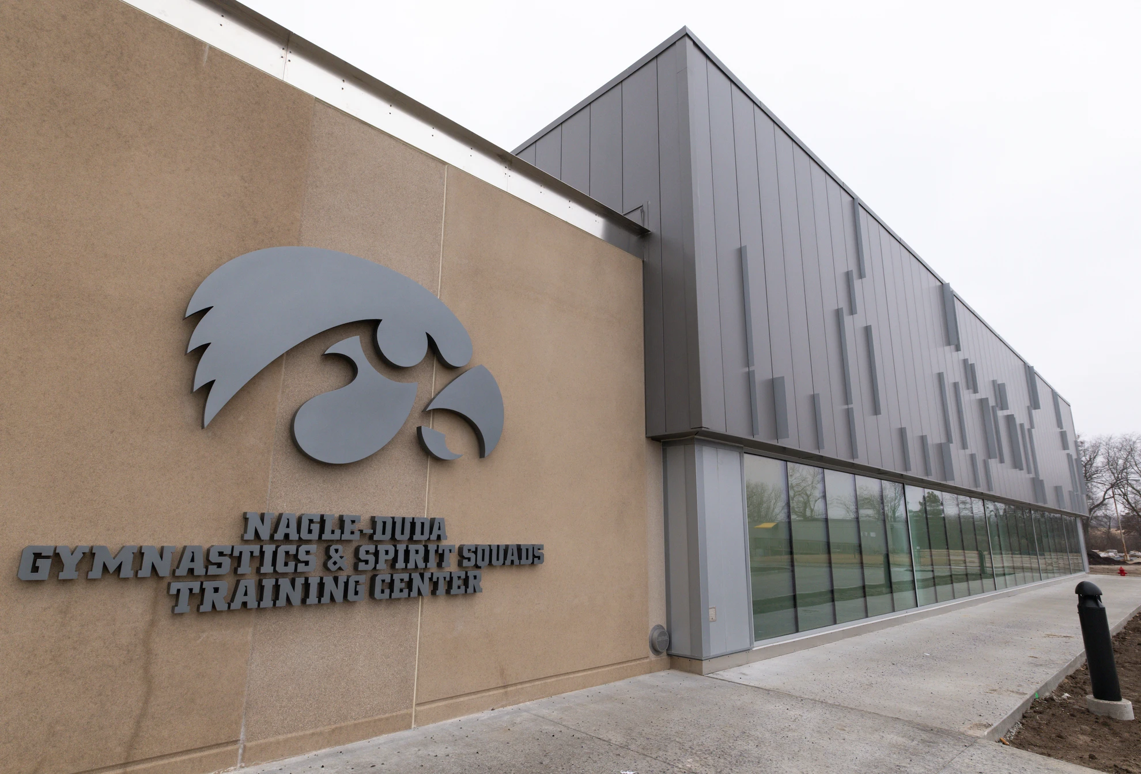 |  | 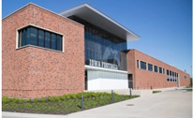 |  | 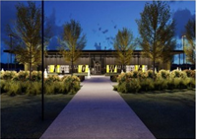
NAGLE-DUDA GYMNASTIC & SPIRIT SQUADS TRAINING  CENTER |  | STEW & LENORE HANSEN FOOTBALL PERFORMANCE COMPLEX |  | GOSCHKE FAMILY WRESTLING TRAINING
 |  | 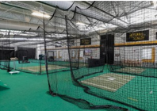
JAMES M. HOAK FAMILY GOLF COMPLEX |  | JACOBSON HITTING FACILITY

RESOURCES

Report A Problem
There are numerous resources within the UI Athletics Department and The University of Iowa campus that can assist you with conflict resolution.
IF YOU HAVE CONCERNS INVOLVING…
YOUR TEAM:
First, speak with your coach…
- Most issues or concerns can be resolved between you and your coach.
Second, speak with your Sport Administrator.
- The role of the sport administrator is to listen to your concerns, recommend solutions and resolve issues pertaining to your sports team.
Third, speak with the Senior Woman Administrator.
- The role of the Senior Woman Administrator includes managing departmental programs and sport management responsibilities.
If you have made an initial attempt to address your concerns with your coach and your sport administrator, the following resources may be of assistance.
- Office of the Ombudsperson (Confidential Resource)
- Student-Athlete Academic Services
- Faculty Athletic Representatives
YOUR ACADEMICS:
- First, speak with your Academic Coordinator…
- Second, speak with your College or Major Advisor
HARASSMENT OR DISCRIMINATION:
- Contact the Office of Civil Rights Compliance (OCRC) (319) 335-0705
- Contact the Dean of Students Office (319) 335-1162
YOUR PERSONAL LIFE:
- Schedule an appointment with the UI Athletics Department Counseling and Sports Psychology Services
- See a counselor in University Counseling Services
NCAA RULES VIOLATIONS
- Contact the Compliance Office at (319) 335-9598
SEXUAL HARASSMENT, SEXUAL MISCONDUCT, DATING/DOMESTIC VIOLENCE, STALKING
- Contact Office of Civil Rights Compliance (OCRC) Title IX (319) 335-6200
- Contact the University of Iowa Department of Public Safety
Additional Resource: Ethics Point is the University of Iowa’s confidential reporting outlet for all potential or suspected wrongdoing.
https://apps.its.uiowa.edu/ethics
SEXUAL HARASSMENT AND MISCONDUCT REPORTING OPTIONS
Information about reporting sexual misconduct is here: https://ocrc.uiowa.edu/
SEXUAL HARASSMENT AND MISCONDUCT POLICY
Information about the Policy on Sexual Harassment and Misconduct is on the OCRC website at: https://diversity.uiowa.edu/daod/ocrc/title-ix-compliance-and-policy .
DVIP & RVAP (Domestic Violence Intervention Program & Rape Victim Advocacy Program) https://dvipiowa.org/

Campus Resources & Services

Admissions
ADMISSIONS OFFICE
2900 University Capitol Centre
http://admissions.uiowa.edu/

Academic Resources
- ENGINEERING LAB
3100 Seaman’s Center
https://engineering.uiowa.edu/ecs
- MATH LAB
125 Maclean Hall
https://math.uiowa.edu/math-tutorial-lab
- WRITING CENTER
110 English-Philosophy Building
http://writingcenter.uiowa.edu/

Advising
ACADEMIC ADVISING CENTER
C210 Pomerantz Center (2nd Floor)
http://advisingcenter.uiowa.edu/

Billing & ID Card Service Center (Formerly UI Service Center)
2700 University Capitol Centre
https://idcard.uiowa.edu/billing-id-card-service-center/
At the UI Billing & ID Service Center, students can accomplish a multitude of tasks ranging from:
- Paying U-Bills
- Changes in registration
- Scholarship check submissions
- Student name changes
- Transcripts and Verifications
- Graduation Services
- Residency
- ID Card Programs
- Billing and Loan Collections
Hours of operation are 8:00 a.m. to 4:30 p.m. Monday through Friday (excluding University holidays).

Campus Involvement
OFFICE OF LEADERSHIP AND ENGAGEMENT
G010 Iowa Memorial Union
https://leadandengage.uiowa.edu/
STUDENT LIFE
249 Iowa Memorial Union
http://studentlife.uiowa.edu/
STUDY ABROAD
1111 University Capitol Centre
https://international.uiowa.edu/study-abroad
UNDERGRADUATE STUDENT GOVERNMENT (USG)
145 Iowa Memorial Union
https://usg.uiowa.edu

Career
COLLEGE OF ENGINEERING CAREER SERVICES
3612 Seamans Center
https://engineering.uiowa.edu/career-services
POMERANTZ CAREER CENTER
C310 Pomerantz Center
http://careers.uiowa.edu/students
TIPPIE COLLEGE OF BUSINESS – CENTERS AND INSTITUTES
108 John Pappajohn Business Building
https://tippie.uiowa.edu/about-tippie/centers-and-institutes

Colleges
COLLEGE OF BUSINESS
108 John Pappajohn Business Building
http://tippie.uiowa.edu/
COLLEGE OF DENTISTRY
801 Newton Rd., Dental Building
https://www.dentistry.uiowa.edu/
COLLEGE OF LIBERAL ARTS & SCIENCES
120 Schaeffer Hall
http://clas.uiowa.edu/
COLLEGE OF EDUCATION
N459 Lindquist Center
https://education.uiowa.edu/
COLLEGE OF ENGINEERING
3100 Seamans Center
https://www.engineering.uiowa.edu/
COLLEGE OF LAW
280 Boyd Law Building
http://law.uiowa.edu/
COLLEGE OF MEDICINE
451 Newton Rd.
http://www.medicine.uiowa.edu/
COLLEGE OF NURSING
50 College of Nursing Building
http://www.nursing.uiowa.edu/
COLLEGE OF PHARMACY
180 S. Grand Avenue
https://www.pharmacy.uiowa.edu/
COLLEGE OF PUBLIC HEALTH
145 N. Riverside Dr.
https://www.public-health.uiowa.edu/
GRADUATE COLLEGE
201 Gilmore Hall
http://www.grad.uiowa.edu/
UNIVERSITY COLLEGE
310 Calvin Hall
http://uc.uiowa.edu/

Counseling Services
UNIVERSITY COUNSELING SERVICES
3223 Westlawn
https://counseling.uiowa.edu/

Dean Of Students
OFFICE OF THE DEAN OF STUDENTS
135 Iowa Memorial Union
https://dos.uiowa.edu

Financial Aid
OFFICE OF STUDENT FINANCIAL AID
2400 University Capitol Centre
http://financialaid.uiowa.edu/

Information Technology Services
2800 University Capitol Centre
https://its.uiowa.edu/

International Programs
1111 University Capitol Centre
https://international.uiowa.edu/isss

Libraries
100 MAIN LIBRARY
http://www.lib.uiowa.edu/

Office of Civil Rights Compliance (OCRC)
202 Jessup Hall, West Jefferson Street
https://ocrc.uiowa.edu/

Office of Enrollment Management
2700 University Capitol Center (UCC)
http://www.registrar.uiowa.edu/

Student Disability Services
141 University Capitol Centre
http://sds.studentlife.uiowa.edu/
*The University of Iowa prohibits discrimination in employment, educational programs, and activities on the basis of race, creed, color, religion, national origin, age, sex, pregnancy (including childbirth and related conditions), disability, genetic information, status as a U.S. veteran, service in the U.S. military, sexual orientation, gender identity, or associational preferences. The university also affirms its commitment to providing equal opportunities and equal access to university facilities. For additional information on nondiscrimination policies, contact the Senior Director, Office of Civil Rights Compliance, The University of Iowa, 202 Jessup Hall, Iowa City, IA, 52242-1316, 319-335-0705 (voice), 319-335-0697 (TDD), daod-ocrc@uiowa.edu

